Agglomeration and Urban Economics in International Climate Policy: A Dynamic CGE Approach

HENRI WAISMAN

*Centre International de Recherche sur l’Environnement et le Développement*

and

FABIO GRAZI[1]

*Agence Française de Développement, Research Directorate*

Agglomeration and Urban Economics in International Climate Policy: A Dynamic CGE Approach

Abstract

Thispaper presents an integrated model of urban agglomeration economies within a computable general equilibrium (CGE) model of global economic activity, energy use and carbon emissions to explore the theoretical and empirical nature of the interdependence of cities and the world economy in a climate policy context. Based on calibration data for 74 major OECD agglomerations, the integrated model is used to gauge the long-term impact of: *i*) global carbon pricing on urban systems and the economic activity; *ii*) urban infrastructure development on the economic costs of curbing carbon emissions. Importantly, it is found that combining urban infrastructure and carbon pricing allows for stringent emissions reduction targets, while still avoiding the economic and welfare costs of the carbon price only. (**JEL**: C68, R12, Q54).

Keywords: Calibration; Cities; Hybrid energy-economy modeling; New economic geography; Trade and transport; Urban infrastructure; Welfare.

Acknowledgments

We are grateful to Carlo Carraro, Gianmarco Ottaviano and John Reilly for helpful remarks and suggestions on a previous version of the paper. All errors are ours.

**1.** **Introduction**

In the wait for an internationally agreed upon framework to tackle global climate change, the climate science and policy communities have started placing increasing attention on the local, and especially urban, dimension of climate mitigation, there where climate impacts from economic activities specifically arise (e.g. IPCC, 2014, Viguié and Hallegatte, 2012; World Bank, 2010; Grazi and van den Bergh 2008). The relation between urban spatial development and climate change runs in two critical directions. On the one hand, the spatial distribution of economic activities in urban areas and its counterpart transport mobility (in terms of commuting needs, and intra- and inter-industry trade) are important drivers of carbon emissions (Glaeser and Kahn, 2010, Grazi et al., 2008). On the other hand, a context of rising cost of fossil fuels affects the trade-off between transport and housing prices and hence the spatial organization of cities (Lampin et al., 2013; Karathodorou et al., 2012; Morikawa, 2012; Waymire and Waymire, 1980). A comprehensive framework which is capable to address the interdependence of cities and the economy, and the complexity of the economic mechanisms underlying it, can be especially insightful for climate policy, where extra emission reduction options are urgently needed to reach very ambitious emission targets. Unfortunately such a comprehensive framework is still lacking.

The overwhelming majority of energy-economy numerical models conventionally used for climate policy analysis focus on the technological determinants of long-term energy trajectories affecting climate change. However, they typically fall short of capturing explicitly the role of cities and space in driving the future energy economy, as demonstrated by the lack of any spatial dimension in energy and climate policy assessment exercises (IPCC, 2014). Our main point here: the traditional approach to climate policy analysis on aggregate frameworks, mostly based on carbon pricing schemes, needs to be extended to explore the mitigation potential of spatial development patterns at the subnational and especially urban scale.

This paper goes beyond the traditional limitation of numerical techniques for energy and climate policy assessment by explicitly describing the interdependence of energy consumption, carbon emissions and the development patterns of cities. This is done in two steps. First we develop a dynamic model of urban systems with location choices and mobility patterns in the light of the new economic geography (NEG) (Krugman, 1991) and urban economics (Alonso, 1964) for the study of positive (economies of scale) and negative (commuting and housing costs) externalities stemming from concentration of economic activities in (urban) space. Combining NEG and urban economics approach is an interesting extension of the literature because—in contrast to most NEG applications—it gives cities a spatial dimension or structure. Our urban spatial model works in a way that, at a given time, it spatially disaggregates a national economy in a set of multiple locations (cities) and describes location choices of firms and workers across them over time. In our setting location preferences by firms go towards those agglomeration markets that offer the most attractive investment opportunities. This is captured through an endogenous attractiveness variable that accounts for anticipation on future returns by investors and location specific characteristics (amenities).

In a second phase, the spatial urban model is coupled with a Computable General Equilibrium (CGE) framework for climate policy and scenario analysis. The resulting integrated CGE and spatial model allows to explicitly build the analytical link between infrastructure investments and production possibilities at the local urban scale and aggregate economic trends and carbon emissions at the global and national scales. The numerical CGE adopted here is the Imaclim-R model, which has been applied to a number of international policy studies (Waisman et al, 2012*a*).[2] Two are the points of innovations that characterize Imaclim-R with respect to other renowned CGE models for climate policy simulation: *i*) the transition costs between two steady-state equilibria are endogenously generated by the interplay of non-perfect foresight and the inertia of technical systems; and *ii*) the material content of economic interactions resulting from technological, behavioral and spatial dynamics is explicitly represented through technical coefficients. These two modeling characteristics are particularly well suited to analyze the complexity of urban phenomena as they enable to capture the uncertainty related to spatial behavior of firms and individuals when multiple locations are available. Moreover allowing for a fine technology description of the transportation and energy sectors is key to providing robust projections of the impact of urban strategy and spatial policy on the aggregate economy in terms of both modal shift and technical change.

The resulting integrated model of cities, space and the world economy is then calibrated over the 2009 OECD Metropolitan Database collecting data for 74 major urban agglomerations of OECD countries (beyond 1 million inhabitants). This allows to account for patterns in OECD cities and the feedback mechanisms that can take place between cities and more aggregate dimensions of the economy, including economic activity, welfare and carbon emissions affecting climate change. The model is then used to carry out three types of empirical analysis, which are motivated by urgent international policy agenda on climate change control (IPCC, 2014). First, we analyze projected trends of OECD cities (including urban population density and land prices) that are consistent with the projected baseline scenario, in absence therefore of any climate policy intervention, where future trajectory of energy prices is driven by long-term energy-intensive economy and resource scarcity. Second, we consider the economic costs of designing a market-based climate policy of the type of carbon pricing (tax) to control carbon emissions, as well as its effect on key determinants of urban economic activity and development in the long term. These are: commuting demand by urban workers, government expenditure on urban public (transport and construction) infrastructure services; and housing prices. Third, we investigate the potential for policy at the urban scale to reduce the economic (in terms of GDP) and welfare (in terms of household surplus) costs of global climate change mitigation, when used as a complementary and alternative intervention to the carbon tax.

The type of policy we have in mind takes the form of redirecting public expenditure (investments + operating costs) toward efficient urban infrastructure system including supply of public transit and construction development. As a result of increased urban spatial efficiency induced by the policy, individual commuting demand would decline (Baum-Snaw, 2010; Bento et al., 2005; Mieszkowski and Mills, 1993; Mills, 1992), and so would the energy used for commuting purposes and the associated carbon emissions (Glaser and Kahn, 2010, Grazi et al., 2008).[3] Public expenditure policy focusing on urban infrastructure would result in altering the spatial structure of cities toward high-density development, which generally goes along with increased efficiency of the transport system and enhanced spatial connectivity and accessibility (Grazi et al., 2008). As the public expenditure policy acts on the spatial structure and development of urban agglomerations, we henceforth refer to it as spatial policy.

The remainder of this paper is organized as follows. *Section 2* describes the integrated model of cities and space in the world economy. *Section 3* offers aggregate (GDP, population, energy) trends and urban projections in absence of any (climate, spatial) policy (the so-called ‘baseline scenario’). *Section 4* presents the policy simulations and discusses: first the effect of climate-control measures in the form of carbon pricing on long-term development patterns of cities (*Section* *4.1*); and secondly, the role of complementary public expenditure on urban infrastructure in designing efficient climate policy (*Section* *4.2*). *Section 5* finally concludes.

**2. Cities and Space in the World Economy**

Here we present our proposed integrated modeling framework of cities, space and the world economy. It serves to investigate the interplay between the local (spatial) and the aggregate dimensions of economic activity, which include, labor and capital migration, urban dynamics, transportation, energy use and associated carbon emissions affecting climate change and economic welfare. The integrated framework consists of designing a simple spatial model inspired by the urban economics (Alonso, 1964; Mills, 1967; Muth, 1969) and the new economic geography (Krugman, 1991) to be next embedded in the Imaclim-R CGE model for climate policy and scenario analysis (Waisman et al., 2012*a*). Due to space constraints, we discuss the overall approach underlying the Imaclim-R CGE model along with few key modeling features (in *Section* *2.1*) and refer the reader to the relevant literature for a complete description (Waisman et al., 2012*a*). As for the spatial model, its rationale is discussed in the body of the article (in *Section* *2.2*) but the full set of equations is provided separately (in the Supplementary Material, *Section A*). Rather, here we tribute the due analytical relevance to the description of the three-step methodological approach leading to the integrated CGE and spatial model, which we consider being the major contribution of this study (see *Section 2.3*). Information on the data used and the calibration method are sketched out here (see *Section* *2.4*) and thoroughly treated separately (in the Supplementary Material, *Section B*).

*2.1. The Imaclim-R CGE Model Modeling Framework*

Computable general equilibrium (CGE) models are numerical instruments developed for long-run forecasting of complex dynamic systems. They are increasingly seen as reliable guides for policy to address the relationship between determinants of economic development and forces inducing climatic variations (Böhringer and Löschel, 2006). CGE models are typically based on multi-regional, multi-sectoral frameworks describing the world economy and the adjustments of production and consumption under counterfactual scenarios representing different visions of the world or policy intervention. They give insights on the economic impacts arising from specific policy interventions through allowing for comparison of different policy measures aimed at CO2 abatement (mainly, carbon taxes/subsidies and emission trading permits) in terms of efficiency, distributional effects and the cost (benefit) pressure exercised on its sectors by a tax (subsidy).

The CGE model used in this study is Imaclim-R, a multi-region, multi-sector, dynamic model designed to develop projections of economic growth, energy system development and related carbon emissions causing climate change (Waisman et al., 2012*a*). It divides the world economy into 12 regions[4] and 12 sectors[5] and generates techno-economic trajectories over the 2001-2100 period in yearly steps through the recursive succession of static equilibria and dynamic modules. The annual static equilibrium provides a snapshot of the economy at each date *t*: relative prices, wages, labor, production value, physical flows, capacity utilization, profit rates and savings at date *t* result from short-term equilibrium conditions of demand and supply on all markets, including that of energy. It is calculated assuming Leontief production functions with fixed input-output coefficients. Households maximize their utility through a trade-off between consumption goods, mobility services and residential energy uses considering fixed end-use equipment. The bottom-up dynamic modules describe changes in input-output coefficients from date *t* to  as functions of technical potentials, expectations on sector profitability and decisions of economic agents. The rate and direction of technical change is bound to availability of capital and to the innovation-possibility frontier [which describes the supply curve of new knowledge à la Kennedy-Samuelson-Weizsäcker (David, 1975)]. Investment decisions are taken under imperfect foresight to capture the inertia on capital, infrastructure and technology (see discussion below).

The CGE Imaclim-R framework describes growth patterns in a second-best setting, i.e. with sub-optimal market adjustments (market imperfections, partial uses of production factors) and transitory departures from first-best dynamic adjustments that are motivated by the inertia of technical systems and capital under imperfect expectations. As a direct implication of this setup, the baseline trajectory does not follow an optimal path. Hence, unlike standard optimization framework, Imaclim-R allows for economic benefits to potentially arise when underlying market imperfections are corrected by implementation of the policy. The set of equations describing the model setting and the numerical assumptions underlying bottom-up modules are not given here for the sake of space limitation but are thoroughly provided in (Waisman *et al*., 2012*a*). Likewise, we omit providing the analytical detail of the transport system and particularly of the role of transport infrastructure investments in determining individual travel behavior via the allocation of time and budget across the set of available transport modes. For a thorough discussion of this critical element of our analysis we refer to Waisman *et al*. (2013b)..

*2.2. The Model of Cities and Space*

The organization of economic activities in space is traditionally investigated by the New Economic Geography (NEG), in line with the seminal paper by Krugman (1991). NEG has proven successful in representing heterogeneous land uses and agents’ location decisions as resulting from the trade-off between benefits and costs of agglomeration (Fujita et al., 1999). Yet, NEG approach falls short of rendering a complete picture of the spatial economy and dynamics as it neglects the internal structure of (urban) agglomerations and therefore of the activities that take place in there—some of which are CO2-emission intense activities and hence particularly relevant in the context of climate change mitigation, which we treat here (Glaeser and Kahn, 2010). To overcome this limitation we combine the typical spatial setting of the NEG approach and the standard urban economics description of cities *à la* Alonso (1964), Mills (1967), Muth (1969). The result is a model of space and cities where spatial decisions are taken not only across multiple urban agglomerations but also within them. The full set of equations describing the general equilibrium of this system of urban agglomeration economies in mutual interaction through trade is detailed by equations (A.1) to (A.49) in the Supplementary Material.

Briefly, a national economy in our model is disaggregated into a mass of  agglomerations (or urban areas) plus one unique rural area, *z*.[6] Each agglomeration  comprises ** firms located in the Central Business District (CBD) and ** households distributed within circular peripheral areas around it. Each urban firm produces ** units of a variety of a composite good, *M*,under variable labor cost submitted to external economies of scale [with unitary labor requirements ** paid at wage rate **, see eq. (A.1)] and fixed capital costs [with uniform amount per firm  paid at a rate of return **, see eq. (A.2)]. At distance *x* from the city’s CBD, households experience urban costs resulting from housing demand and commuting costs due to their daily travel to the CBD (where jobs and shops are located). Housing costs depend on the demand for housing surface  [see eq. (A.7)] and the equilibrium land rent level . Commuting costs  are modeled in the ‘iceberg form’ (Samuelson, 1952), with parameter  measuring unitary losses of effective labor ** caused by the daily trip to CBD [eq. (A.9)]. Utility maximization under income constraint gives demand for the differentiated good *M* [eq. (A.11)] anda homogeneous *z*-specific good, *F* [eq. (A.13)]. Household income formation includes wages, dividends from capital investments and the (redistributed) revenues from land [equations (A.15) to (A.19)].

The spatial extension of the city ** is decided by local government according to a trade-off between commuting costs [eq. (A.22)] and investment costs [eq. (A.23)]. In the rural area *z*, land is considered as a homogenous space in which the ** households are strictly identical and experience no external costs. Firms produce ** units of a homogenous good, *F*,under constant returns to scale with two input factors: labor (with unitary requirements ** and wage rate **) and capital (with unitary requirements ** and return rate **) [eq. (A.27)].

In order to allow the model for the spatial dimension, trade is permitted across agglomerations, as well as between agglomerations and the rural area, and transport costs are represented under a ‘iceberg’ formulation *à la* Samuelson (1952) [see equations (A.36) and (A.37)]. The homogenous good produced in the rural area is freely traded, so that its selling price is identical in all agglomerations and equals the selling price in the rural area  where it is produced: .

The short-term equilibrium of the model is defined by a set of four conditions. Market equilibrium for the differentiated good under monopolistic competition *à la* Dixit-Stiglitz (1977) gives equilibrium quantity ** [eq. (A.38)], price ** [eq. (A.39)], and returns to capital ** [eq. (A.40)]. Market equilibrium for the homogenous good under perfect competition gives equilibrium quantity ** [eq. (A.41)] and price [eq. (A.42)]. Given total effective labor supply in each urban agglomeration *j*, ** [eq. (A.43)], the labor market equilibrium conditions gives total labor needs in each urban economy [eq. (A.44)] and in the rural area [eq. (A.45)]. Finally, the spatial equilibrium imposes that utility levels are identical in all agglomerations and the rural area [eq. (A.49)].

*2.3. The Integrated Model of Cities, Space and the World Economy*

Here we extend the short-run urban model in *2.2.* to address the dynamics of cities and ensure analytical consistency for their integration in the CGE model, Imaclim-R. In a technical modeling sense, the urban model is included as a dynamic module of Imaclim-R (see previous discussion), which allows for endogenous bilateral exchange of information between the urban systems and the aggregate economy in three methodological steps: 1) the economic activity at the national and regional scales is spatially disaggregated into a mass of urban systems and a rural area, consistently with the set of spatial equations developed in previous subsection; 2) dynamics of cities and space is captured through population (workers) migration and firm mobility over time; and 3) the key variables driving the dynamics of cities are aggregated up and included in the set of equations describing the adjusted economic activity at the national and regional scales. Figure 1 provides a schematic representation of the three methodological steps leading to the integrated model of cities and the economy.

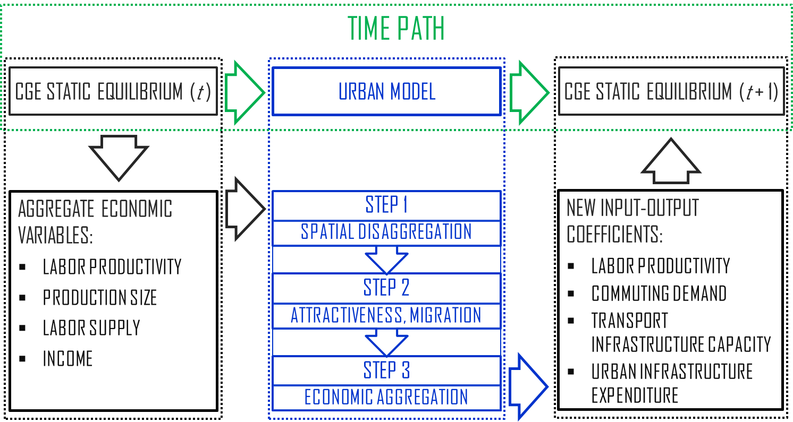

Figure 1: Schematic representation of the integrated city-economy model

At each time step *t*, the urban model in *2.2* receives information from the CGE static equilibrium at date *t* in the form of aggregate economic variables (namely, size of national production, labor force and productivity, income) (Step 1). Updated input-output coefficients resulting from changes in the urban structure (Step 2) are sent back to the CGE economy to calculate the adjusted aggregate economic variables (namely, transport demand for commuting purposes, transport infrastructure capacity, public expenditure on urban infrastructure, and labor productivity) of the new static equilibrium, at date  (Step 3).

*2.3.1. Spatial disaggregation of economic activity (Step 1)*

At date *t* the Imaclim-R static equilibrium is disaggregated into a set of urban agglomerations as defined by the spatial model in *2.2* and formally described in the Supplementary Material. Technically, the spatial disaggregation comes down to solving the system of equations that defines the urban economy [equations (A.1) to (A.49) in the Supplementary Material] subject to the boundary condition that the average (over the number of urban agglomerations) value of each *urban* variable equals the value of the corresponding *aggregate economic* variable in Imaclim-R. So, by noting , ,  and  the national aggregate value of, respectively, total production, totally available (effective) labor force, wage rate, and population from the Imaclim-R static equilibrium at date *t*, consistency of aggregate and urban variables is ensured by the following set of equations:









In addition to the above four consistency equations at the national scale, we study the behaviour of two crucial urban agglomeration-specific determinants of economic activity, namely: unitary commuting costs, ; and labor productivity, .

Commuting-related income losses faced by households in agglomeration *j*, amount to  per kilometer (eq. A.10 in the Supplementary Material) and are assumed to proportionally depend on the energy cost for travel needs.[7] This indicator is determined from the domestic price of liquid fuels,, and the unitary fuel consumption from vehicles, , both indicators being calculated by the Imaclim-R static equilibrium at date *t*. We therefore obtain the following relation: , where *β* is a constant. With notation  indicating the value of the above set of parameters at the base (calibration) year, commuting costs in urban agglomeration *j* can then be written as follows:



Growth trajectory at the national level is driven by exogenous gains in domestic labor productivity, which results in decreased unitary requirement for production, , in Imaclim-R static equilibrium. This is reminiscent of Solow (1956)’s exogenous technical progress controlling growth trends. For the sake of simplicity, we assume that domestic productivity gains are uniformly distributed across the urban agglomerations, so that the relative gains of local productivity are identical in all urban economies. This implies setting:



*2.3.2. Urban dynamics in attractiveness and firm migration (Step 2)*

The disaggregated spatial economy obtained at step 1 identifies three main determinants of urban patterns in each agglomeration *j*, upon which heterogeneity across agglomerations originates: *i*) type of available labor force, as captured by labor productivity, ; *ii*) quality and nature of transport infrastructure, as reflected by unitary commuting costs ; and *iii*) amenity of urban space, described as the utility derived from living in urban site *j*, . At the equilibrium, the heterogeneity of the three determinants among agglomerations raises differences in the rate-of-return of capital [see eq. (A.40)]. On this basis, a *j*-specific attractiveness index, **, is built that reflects firms’ incentive to settle in agglomerations that show the highest return to capital. Attractiveness differentials drive migration decisions by firms as captured by assuming that the relative variation of the number of firms in a given agglomeration *j*, , is an increasing function of its attractiveness index **. Assuming linear dependence for the sake of simplicity, we have:



where  is a threshold level defining the minimum value of attractiveness to attract firms. Parameter  hence controls the total variation of the number of firms , as given by:



The number of firms in agglomeration *j* at date *t* is then given by:



*2.3.3. Aggregation of local variables (Step 3)*

The third step of the inclusion of the urban model within the CGE framework consists in aggregating up information concerning the market and spatial structure of the local economy to obtain an updated picture of the key spatial drivers of the aggregate economic activity. For the purpose of applying the model to policy-relevant questions in the context of energy and climate change, we focus on four spatial drivers of domestic demand on energy and of associated carbon emissions causing climate to change: *i*) transport demand (for commuting purposes); *ii*) transport infrastructure capacity; *iii*) public expenditure on urban infrastructure; and *iv*) labor productivity.

1. As we model the city economy, households living in urban agglomeration *j* consume  units of land and commute to the Central Business District (CBD). Commuting demand linearly depends upon the distance commuted in a given agglomeration *j*, . With (A.7), latter is as follows:



where  is a constant (see eq. A.7). Note that by above definition of , the inverse function, , captures then the average population density of city *j*.

The aggregate commuting demand at the national level, ** is then given by the sum of commuting distances over all agglomerations:



1. Urban form affects the type of transport mode used for travel purposes and hence influences the supply of transport infrastructure facilities in a given agglomeration (Glaeser and Kahn, 2010; Grazi et al., 2008; Bento et al., 2005). More precisely it appears that urban density (sprawl) tends to favor public transportation infrastructure (private vehicle road) development. We then consider supply of public transport facilities, defined by the amount of transport capacities of public modes , being an increasing function (which is assumed linear for simplicity) of the average aggregate density, as defined by the ratio between urban population and the spatial extension of urban areas:

.

In our model, (investment and operating) spending on urban infrastructure depends on the density of settlements within each urban agglomeration. Although simplified, such approach allows us to endogenously capture the relation between supply of urban infrastructure and urban economic development through accounting for high marginal construction costs in the construction sector and the need for developed transport infrastructure in dense cities (Eberts and McMillen, 1999). For the sake of illustration, we assume that infrastructure expenditure requirements are met by the government and ultimately affect household income through public transfer mechanism.[8]

By introducing  as a measure of the non-linearity of capital to be invested in function of the local density , per-capita urban public infrastructure expenditure, , increases with density:[9]

,

where  normalizes the units of measurement and captures the share of public spending on infrastructure going to urban (building + transport) infrastructure.[10]

The amount of public spending on urban infrastructure in the *j*-agglomeration, , is then given by:



The total amount of government expenditure on urban infrastructure at the domestic level, *I*, is then defined by the sum of required spending over all agglomerations:



1. Finally, the relocation of production among agglomerations of different productivity values implies changes in the average productivity at the national level. The relative change in productivity  resulting from firm migration decisions is given by:



*2.4***.** *Data and Calibration*

Calibration of the Imaclim-R model is based on the GTAP-6 database, which provides a set of balanced input-output tables of the world economy (Dimaranan, 2006). Technically, calibration results from aggregating up GTAP input-output tables according to the Imaclim-R mapping in 12 regions and 12 sectors. Other data sources (providing information in physical quantities) are also used to parameterize the energy and transportation sectors. The hybrid matrix ensuring consistency of money flows and physical quantities is built by modifying input-output tables from the GTAP-6 dataset to make them fully compatible with 2001 energy balances from IEA (in Mtoe) and passenger mobility (in passenger-km) from Schafer and Victor (2000).

The calibration process adopted for the model of urban economies presented in previous subsections starts with the definition of the (group of) region(s) under consideration and the associated urban agglomerations. For the sake of data availability, the numerical analysis is performed on four OECD macro-regions [USA, Canada, Europe (EUR)[11] and OECD Pacific[12]], in which we identify 74 metropolitan regions in total, which represent 37% of OECD population and 48% of OECD GDP.[13] For each metropolitan region (hereafter referred to indifferently as “(urban) agglomeration” or “city”), we reproduce the base year (2001) value taken from the OECD Metropolitan Database of the: number of households; urban size; wage rate; total production; commuting cost. Supplementary Material, *Section B* provides the list of the 74 urban agglomerations and the calibration values of the agglomeration-specific variables by macro-region.

**3. Cities and the Economy: The Baseline Case**

This section describes aggregate trends (GDP, population size, energy markets) and future urban development that are expected to occur in the ‘BAU scenario’, defined as the continuation of the actual economic status, with no policy shock aiming at climate change control.[14] The purpose here is to identify the underlying mechanisms of the interdependence of economic, energy and spatial systems with the integrated model described in *Section 2*.

Concerning the baseline economic setting, national demographic trends in OECD countries derived from medium UN projections feature a small decrease of total population over 2010-2100 (from 1.15 to 1.07 Billion persons) (UNDESA, 2007). Yet productivity gains are sufficiently high to ensure a steady increase of economic activity at an average growth rate of 1.3% over the same period.

As for the energy side of the story, total primary demand increases from 5.94 GTep in 2010 to 7.45 GTep in 2100. This rather moderate increase is permitted by average annual energy efficiency gains of 1.1%. The simulation period is marked by depletion of oil reserves resulting in a sharp increase of oil prices [Figure 2(a)] and in a progressive switch in the energy mix towards coal (which remains the most abundant fossil energy resource) and renewable energies [Figure 2(b)]. OECD carbon emissions increase from 15.5 GtCO2 in 2010 to 21.5 GtCO2 in 2100 along with diffusion of coal liquefaction as the major substitute to oil for liquid fuel production in the second half of the century.

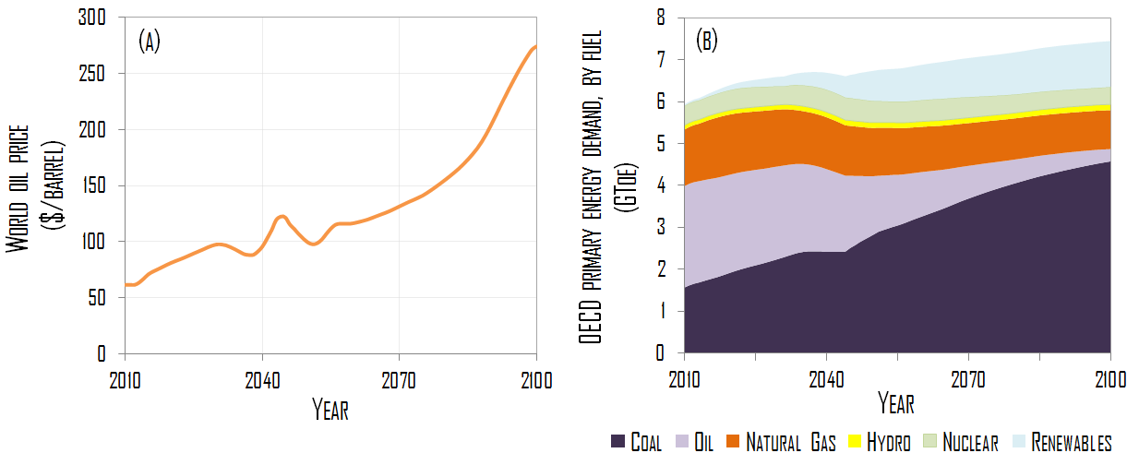

Figure 2: Modeled baseline trend of: (a) World oil price; and (b) OECD primary energy demand (2010—2100).

The integrated model developed in the previous section endogenously provides urbanization trends that are consistent with the above described economic trends in each of the four OECD regions (USA, Canada, Europe, OECD Pacific). In a given region, the distribution of total production across the major urban agglomerations and the rural area is driven by migration decisions of firms on the basis of location-specific differences in the attractiveness of productive investments. The endogenous attractiveness mechanism ultimately determines: *i*) the share of total population living in urban (metropolitan) agglomerations with more than 1 million inhabitants in 2001 (Table I); and *ii*) the dynamics of urban spatial structure, as captured by changes in average urban density and average urban land price by region (see Figure 3).[15]

Table I: Share of total population in the largest urban agglomerations (%)

|  |  |  |  |  |  |
| --- | --- | --- | --- | --- | --- |
| OECD Region | Year | | | | |
|  | *2010* | *2020* | *2030* | *2050* | *2100* |
| USA | 39.1 | 39.4 | 39.0 | 37.3 | 34.4 |
| Canada | 36.5 | 35.6 | 34.8 | 32.2 | 31.7 |
| Europe | 25.2 | 24.7 | 24.4 | 22.9 | 22.3 |
| OECD Pacific | 51.2 | 49.5 | 48.5 | 45.4 | 41.1 |

Concerning the share of total urban population, Table I shows a decreasing trend for the largest agglomerations in all regions. This needs not to be interpreted as a result of migration patterns from urban to rural areas, but rather from larger to smaller urban agglomerations, which are projected to become attractive in the long term. Note that the decreasing trend captures a reversal with respect to observed trends over the 20th century, during which the largest agglomerations have taken an increasing share of total population. Reason for this is that energy prices were historically low in the 20th century, favored the dispersion of settlements in large agglomerations, whereas they are projected to increase significantly over the 2010-2050 period, hence making it desirable to settle in smaller agglomeration, where energy-intensive transportation is less costly due to reduced average travel distance (Bento et al., 2005).

As for the local spatial scale of our analysis, we observe that metropolitan agglomerations feature moderate densification in the first half of the century, and dispersion of urban settlements in the long term [Figure 3(a)]. This pattern is driven predominantly by the unitary cost of fuels for transport driving location decisions, which in turn depends on energy prices and energy efficiency of vehicles. Between 2010 and 2050, the volatile yet strongly increasing price profile of crude oil [Figure 2(a)] yields a sharp increase in price of conventional liquid fuels for transport purposes over the same simulation period. In line with individual utility maximization behavior, this leads to densification of urban settlements in the attempt to minimize unitary transport commuting distance and costs. After 2050, the penetration of coal-to-liquid as an abundant substitute to oil contributes to limit the price increase of liquid fuels despite the rise of oil prices [Figure 2(b)]. The additional effect of energy efficiency in motor vehicle industry favors a decrease in unitary commuting costs, which ultimately fosters urban sprawl. Urban land prices vary accordingly [Figure 3(b)]. They rise during the first phase of densification and decline gradually when the densification trend falls in the long term.

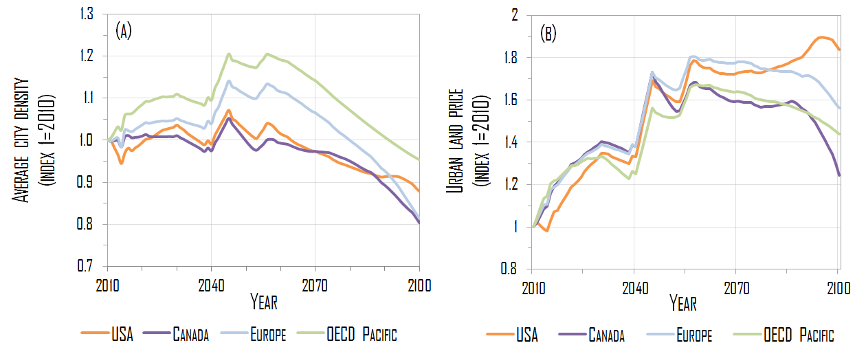

Figure 3: Modeled baseline trend of: (a) Urban Population density; and (b) Urban land price (2010—2100).

As an important consequence of technical, price and spatial trends, total travel demand by private automobile and public transit increases by 58% on average in the four macro-regions, but at a different pace: private automobile use increases much faster than public transit modes over the period 2010-2100 (+ 62% vs + 35%, respectively, as reported in Table II further below).

**4. Cities and the Economy under Alternative Policy Scenarios**

Here we introduce a climate policy as a shock in the model setup and assess its impact on economic welfare for the OECD region. We then take the next step of simulating the long-term interplay of climate policy and the patterns of cities described above. In particular we are interested in analyzing the consequences of a ‘carbon-price only’ policy on energy markets, economic activity and urban dynamics (*Section* *4.1*), and in further assessing the feedback effect of specific measures at the urban scale on the aggregate cost of a climate policy (*Section* *4.2*). Latter comes down to considering the economic performance of a hypothetical climate policy architecture in which an internationally agreed price (tax) on carbon is complemented with a spatial policy of the type of enhanced urban infrastructure development.

*4.1. Setting an International Carbon Tax*

The starting point of our climate policy analysis is the carbon emissions trajectory defining the maximum level of carbon emissions “permitted” at each year step of the simulation period [Figure 4(a)]. For the sake of simplicity, the emission trajectory is exogenously taken from category II of IPCC scenarios corresponding to a stabilization target of 440-485 ppm CO2 and includes a peak of global CO2 emissions in 2017, as well as a decrease by 20% and 60% with respect of 2000 level in 2050 and 2100, respectively (IPCC, 2007, Table SPM5). Our integrated model endogenously calculates the carbon price to be set on the economy in order to satisfy this emissions stabilization goal at each point in time [Figure 4(b)].

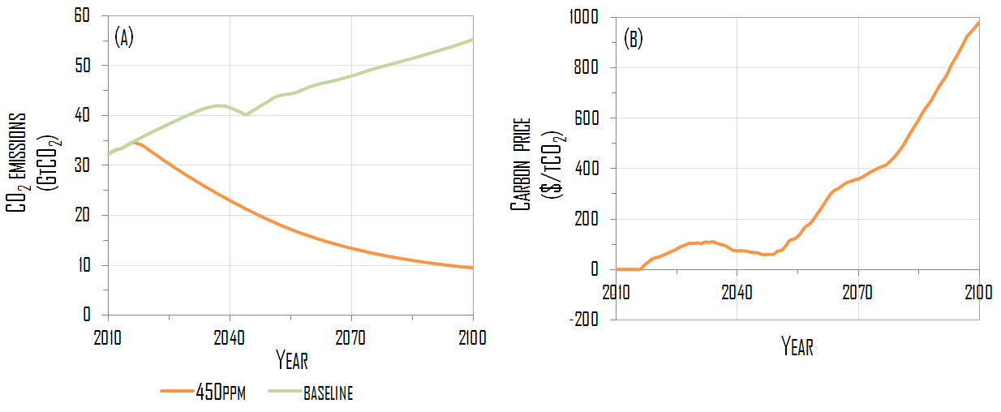

Figure 4: (a) CO2 emissions in the baseline vs climate policy (450 ppm CO2) scenarios; and (b) Carbon price trajectory under climate policy (2010—2100).

In Figure 4(b), the carbon price follows a trajectory that can be clearly distinguished in three phases. In the short-term, the price of carbon increases rather sharply and exceeds 100 $/tCO2 in 2030, so as to provide the economy with a strong early signal to trigger emission reductions. In the medium-term (2030-2060), the carbon price tends to decline and stabilize around 50 $/tCO2. As the general equilibrium mechanisms reveal, this is considered being a sufficient price level to assure that significant mitigation potentials are achieved in the industry, residential and power sectors, which represent the core of emission reductions targets. Finally, in the long-term, the carbon price features a sharp increase, which is motivated by the need to cover the high-cost mitigation efforts at the margin, especially in the transportation sector.[16]

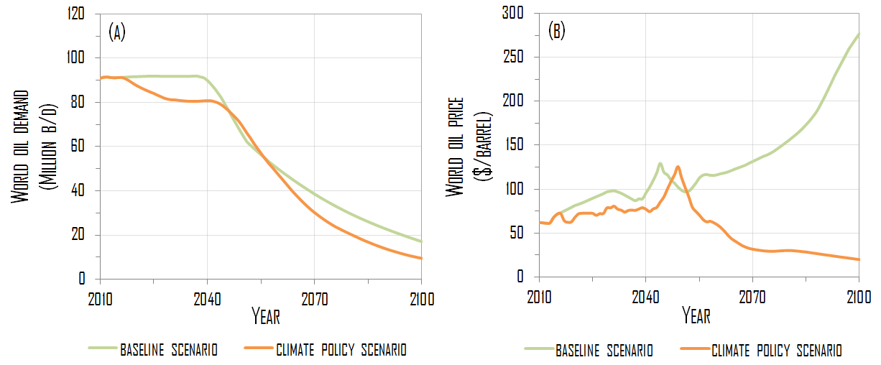

Figure 5: (a) World oil demand; and (b) World oil price, under baseline and climate policy scenarios (2010—2100).

Introducing the carbon tax turns out to affect international oil markets as it shrinks the demand on oil through, on the one hand, raising the cost of fossil fuels in the short run and, on the other hand, stimulating technical change and consequently energy efficiency in the long run (in 2100, oil demand is 45% lower than in the baseline scenario) [Figure 5(A)]. The curtailed dependence on oil under climate policy eases the tensions on international oil market as reflected by lower oil prices than in the baseline scenario (i.e. without carbon price) [Figure 5(b)]. Note that the divergence of price trajectories in the climate policy scenario vs the baseline one is particularly pronounced in the second half of the century. Two factors concur to explain this. On the one hand, supply-side constraint due to oil depletion causes oil prices to rise in the baseline scenario (Waisman *et al*, 2012*b*). On the other hand, demand on oil stabilizes because of the introduction of the carbon tax, which alleviates the tensions in the oil market and induces a decrease of oil prices under the climate policy scenario.[17]

Next we turn to study the effect of the climate policy on the spatial setting of the economy. The carbon-tax type of policy alters the cost of urban mobility, as measured by the variations in unitary commuting costs (per km) [Figure 6(A)]. Costs increase is a direct consequence of the rise of the cost of fossil fuels as a result of the tax and of the dynamics of international energy prices analyzed above. During the first half of the century, the price of liquid fuels experiences a small increase with respect to baseline levels (around 10% in most regions) because the additional costs of fuel in the climate scenario are partially offset by the decrease in oil prices. In the second half of the simulation period, unitary commuting costs in the climate scenario tend to increase more substantially despite the fall of oil prices. At that time, liquid fuels are projected to be essentially produced from coal liquefaction (coal-to-liquid), which enters as a substitute to oil-based production. Since the cost of this carbon-intensive fuel is particularly sensitive to the sharp rise of long-term carbon prices, it drives an increase of unitary commuting costs. This increase in turn acts as an incentive to adopt alternative strategies of urban spatial development which would reduce the distance to commute, as captured by the increase of average urban density in Figure 6(b).

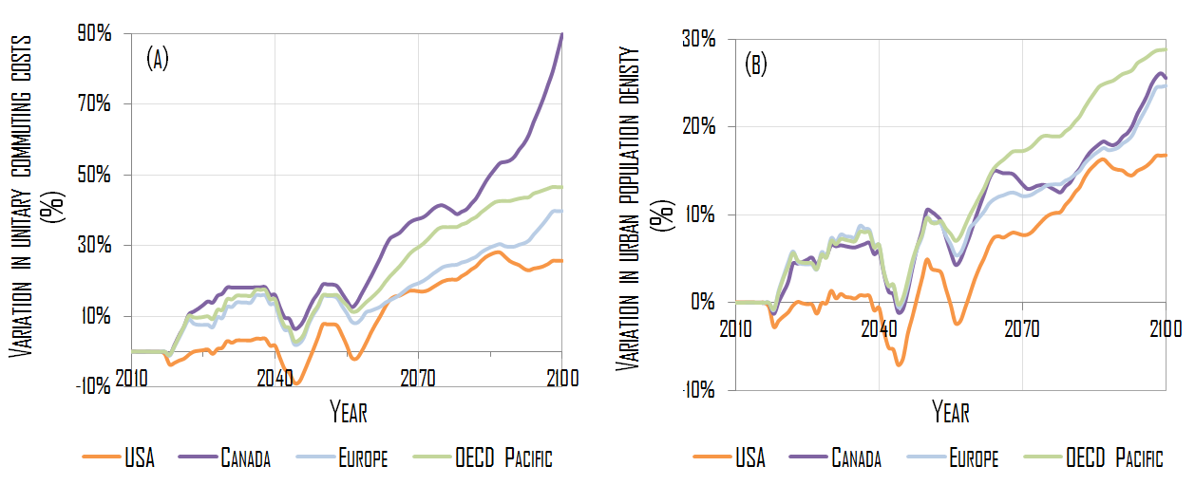

Figure 6: (a) unitary commuting cost; and (b) urban population density, under climate policy scenario with respect to the baseline (2010—2100).

The densification process calls for a redirection of government expenditure towards the urban infrastructure sector as motivated by the construction of new and tall buildings and expansion of public transit system. With the formulation of per capita expenditure, , adopted in the model [see equation (14)], such additional spending with respect to the baseline amounts to 12 Billion$. As competition for land is more intense in densified areas than in sprawled settlements, the densification process fostered by the climate policy brings about the rise of land prices (see Figure 7). Such effect is particularly important in the second half of the century, the 15-30% rise of density resulting in a 30-50% rise of land prices in 2100.

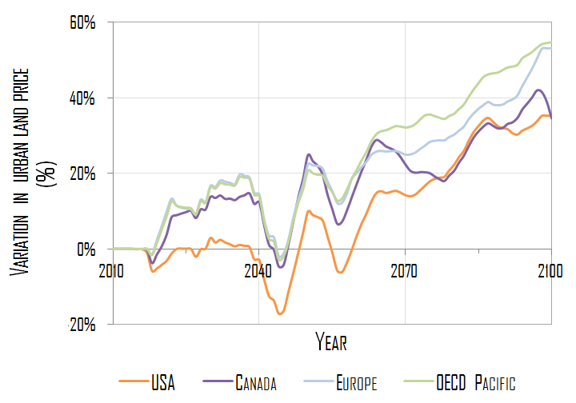

Figure 7: urban land price under the climate policy scenario with respect to the baseline scenario (2010—2100).

The introduction of a price on carbon has a moderate effect on total terrestrial transport (automobile and public transport) volume. This is no surprise as transport (especially commuting) patterns feature low responsiveness to price signals, as nearly identical growth rates of total travel volume across the two scenarios demonstrate (see Table II). Still, implementing a carbon tax policy influences modal shift from private motorized vehicles to public transit, as a result of changes in relative prices between the two modes. This is accompanied by additional increase in public transport demand (a 41% increase of travel demand in the carbon tax scenario against a 29% increase only in the baseline case), against modest reduction of private vehicle use (+39% in the carbon tax scenario against +43% in the baseline case). Note however that, consistently with the weak sensitivity of transport patterns to price signals, changes in overall modal share are small (with public transit representing 14% of total traveled distance in 2100 under the baseline scenario, against 15.5% under the carbon pricing scenario).

At the aggregate scale of the modeling analysis, the economic effects of the climate policy are conventionally measured by GDP variations so as to reflect the policy-induced net costs on the production setting [Figure 8(a)]. Following standard approaches in welfare economics (Willig 1976), we consider additionally consumer surplus to measure climate policy-related effects on the economy. Reason for adopting additional welfare indicator is that consumer surplus allows to account (in money value) for induced welfare variations when income effects are small (Jaccard et al., 2003) [see Figure 8(b)]. In the case of individual travel behavior—which is of great interest here because of implications on both urban spatial structure and transport-related energy use contributing to climate change—considering consumer surplus enables to distinguish between constrained mobility (commuting, essentially) and other types of mobility in terms of welfare effect. If in fact all types of transport activity positively contribute to GDP, constrained mobility associated to commuting cannot be considered as positively affecting economic welfare.

When considering the aggregate effect of the climate policy in terms of GDP and consumer surplus indicators, the general picture we obtain is qualitatively similar in the two cases. In line with above analysis of the three phases of carbon price, we obtain significant short-term economic and welfare losses, a medium-term partial recovery of GDP during which households catch up to baseline utility level, and a final drop of economic and welfare indicators. GDP recovery is made possible because of the second-best setting of Imaclim-R model, which allows for potential economic benefits as an outcome of the climate policy (see discussion in *Section 2.1*). Note, however, that surplus losses are lower than GDP reduction in the long-term (2.1% versus 3.8% in 2100, respectively). This reflects the possibility for consumers to adjust their consumption patterns in response to carbon pricing, notably by adopting efficient end-use equipment and re-orienting their demand towards low-carbon goods. Such adaptive behavior allows consumers to partially counter the rise in energy prices.

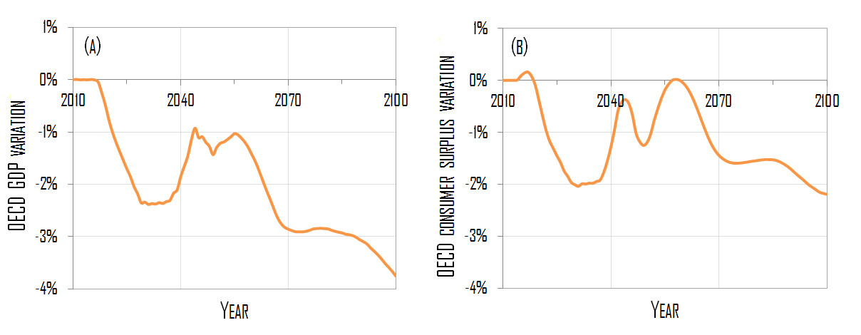

Figure 8: (a) OECD GDP; and (b) OECD Consumer Surplus, under climate policy scenario with respect to the baseline (2010—2100).

*4.2 Combining Climate and Spatial Policies*

The analysis carried out in the previous section shows that the economic and welfare costs of a climate policy remain important if such policy relies essentially on the implementation of a carbon price, especially after 2060. This section considers broader climate policy architecture than the one consisting of carbon tax only, and which combines global carbon pricing scheme and urban spatial policy in a context of given carbon emissions target. The idea of policy complementarity is to offer alternative options to pricing strategy that contributes to reduce global carbon emissions without increasing the cost of mitigating climate change. The spatial policy suites the purpose as, through acting on the spatial structure of urban agglomerations, it allows to reduce average commuting distances (Bento et al., 2005) and related carbon emissions (Glaser and Khan, 2010), and hence to lessen the amount of tax that would be necessary to achieve the emissions target, in absence of the spatial policy. It takes the form of enhancing public spending in building and transport infrastructure , so as to simultaneously foster densified urban space (by, e.g. expanding the building surface area through acting on the land occupancy coefficient) and modal shift away from automobile use (by, e.g. increasing public transit supply and network capacity). Policy outcome would then be consistent with an efficient use of energy and limited carbon emissions from commuting demand reduction and shift to low-carbon modes. It would then be in line with efforts to controlling climate change (Glaeser and Kahn, 2010; Grazi and van den Bergh, 2008; Grazi et al., 2008). For illustration purpose, we assume that, after progressively entering in force, the total amount of annual public investments reaches 0.1% of OECD GDP.[18]

Findings from the analysis with the integrated CGE and spatial model show that, in 2100, the urban policy permits an average 70% increase of spatial density and leads to a 5.9% decrease of total OECD emissions from terrestrial transport (-106 MtCO2). This is the result of a slowdown in total travel volume growth in the combined (“carbon price +spatial policy”) climate scenario with respect to the (“carbon-price only”) climate policy scenario (+27% instead of +40%), as reported in Table II.

Table II: Travel demand in the four macro regions under the three scenarios (by travel mode, in volume and growth rate)

|  |  |  |  |  |
| --- | --- | --- | --- | --- |
|  |  | Private automobile | Public transit | Total terrestrial transport |
| Travel demand by mode, 2010 [*in* *1012 pkm*] |  | 14.9 | 2.7 | 17.6 |
| Variation of travel demand, 2010-2100 [*in %*] | BAU scenario | +43% | +29% | +41% |
| Climate policy scenario  (carbon-price only) | +39% | +41% | +40% |
| Combined policy scenario  (carbon price + spatial policy) | +19% | +71% | +27% |

The carbon emissions reduction potential of the combined climate and spatial policy essentially comes from reduced automobile use for commuting in response to changes in the urban spatial structure (i.e. densification), as demonstrated by the sharp deceleration of the growth rate of travel demand by automobile with respect to the “carbon-price only” policy scenario (a 19% increase against a 39% increase respectively). In addition to the direct effect of reducing the travel demand by polluting cars, the spatial policy indirectly acts on individual travel behavior so as to induce the modal shift towards public transport means, there were public transit infrastructure are developed, and notably in compact urban areas. This explains simultaneous the rapid growth of travel demand by public transport modes under the combined policy scenario policy (+71% instead of +41%). The overall effect is a significant reduction of emissions from private car (-152 MtCO2 in 2100) and a partial rebound of emissions from public transit (+46 MtCO2 in 2100) [Figure 9(a)].

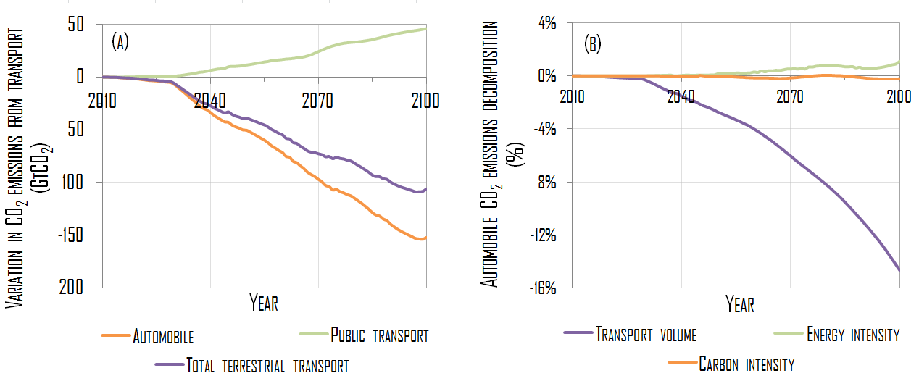

Figure 9: (a) transport-related co2 emissions; and (b) disaggregated emissions from the automobile sector, under combined (climate and spatial) policy scenario with respect to the climate policy scenario (2010—2100).

To shed light on the underlying mechanisms of carbon emissions from transport and their relative role in driving policy-induced CO2 emissions reduction, we adopt a ‘Kaya’ decomposition (Waggoner and Ausubel, 2002; Raupach et al, 2007). In the case of the transportation sector, this comes down to decomposing carbon emissions along three drivers: travel volume (in *passenger kilometers*); energy intensity of the vehicle fleet (in *liters per kilometer*); and the carbon intensity of motor fuels (in *grams of CO2 per kilometer*):



The graphical analysis in Figure 9(b) reports the relative variations of the three factors of the Kaya identity, when the urban policy is set in place. Not completely unexpectedly, the key determinant of carbon emissions reduction under urban spatial policy is the decrease (up to 14% in 2100) in average commuting distance and transport-related energy use resulting from densified space and enhanced intermodal transport system (which arrives at). Simultaneous general equilibrium effects also occur that affect the carbon intensity and the energy intensity of vehicles as a result of the policy. In particular, the decrease in liquid fuel demand as associated to reduced commuting distances endogenously causes liquid fuel prices to drop. Fuel prices fall ultimately slows down technical change towards energy-efficient vehicles, which results in automobile vehicles being 1.1% less efficient in 2100 under the urban densification policy.

At the aggregate level, by contributing to lower transport-related carbon emissions with respect to the “carbon price only” policy scenario, implementation of additional complementary spatial policy results in increasing efficiency of the economy.[19] The direct effect of urban spatial policy remains moderate with respect to the global effort. The 106 MtCO2 emissions reduction from terrestrial transport in 2100 represents only 2.6% of total OECD emissions at the same time horizon and the carbon price to be imposed is decreased by only 2.5%. In terms of global activity as measured by GDP variation, in 2100 the economy with combined climate and spatial policies is 0.2% as rich as in the “carbon price only” policy scenario The impact of combined policy on GDP is moderate, especially when compared to the long-term economic costs of reducing carbon emissions (-3.7% of GDP in 2100) [Figure 10(a)]. Note in passing that although moderate, economic return of combined policy exceeds the costs of implementing the spatial urban policy (estimated at 0.1% of total OECD GDP).

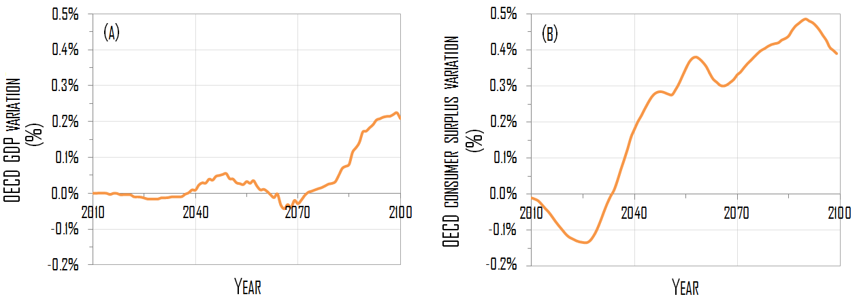

Figure 10: (a) OECD GDP and (b) OECD consumer surplus, under combined (climate and spatial) policy scenario with respect to the climate policy scenario (2010—2100)

The incidence of coordinated climate and spatial policies on the aggregate performance of the economy changes significantly, when considering consumer surplus instead of GDP. In 2100 the economy under combined policy scenario is projected with 0.5% increase in consumer surplus. This is significantly positive welfare effect if compared with the 2.1% total welfare losses under the ‘carbon price only’ scenario at the same simulation date [Figure 10(B)]. Note that welfare under combined climate and spatial policies is relatively low during the first period of the simulation because the additional spending required at an early stage to deploy urban infrastructure come from government budget, which ultimately affect household income through public transfer mechanism. Enhancement of welfare under adequate spatial planning and policy is one of the key insights of the current analysis, as it highlights the relevance of the local (urban) spatial dimension of climate change mitigation policy. In particular, a set of tools that can act alternatively and complementarily to carbon pricing schemes is rendered available that can limit carbon price-related negative welfare effects, when the second best setting of the economy is accounted for. This is especially relevant in a climate policy context where actual trends and projections in transport energy use are weakly responsive to price signals (Waisman et al, 2012*a*).

**5.** **Conclusion**

This paper has developed an integrated framework of urban agglomeration economies within a computable general equilibrium (CGE) model of global economic activity, energy use and carbon emissions to investigate the interplay between the local (spatial) and the aggregate (economic and environmental) dimensions of energy and climate policy. This was done in two phases. First we built a model of cities and space that combines urban economics and new economic geography approaches, and which allows for spatial decisions by households and firms to be taken not only across multiple urban agglomerations but also within them. Then we took the next steps of embedding it into the Imaclim-R model, a recursive dynamic CGE model for climate and energy policy assessment in a second-best setting (which accounts for, among other aspects, inertia of technical systems). The resulting integrated model was used to explore the theoretical and empirical nature of the interdependence of cities and the world economy in a climate policy context, which includes urban (slow) dynamics, transportation and energy system development, energy use and related carbon emissions affecting climate change, and economic welfare. Our approach strongly departed from the existing literature on energy-economy modeling by adding formalized spatial urban dimension to the standard global and aggregate approach generally adopted for climate policy analysis.

By means of the integrated model, this paper has addressed two relevant issues in the context of climate change. First, it has analyzed the effects of economic activity, oil price trajectory and technical change on the long-term dynamics of urban systems. It has shown in particular that rise in fuel price, by increasing the costs of commuting in urban areas, leads to future high-density development of OECD cities, whereas both penetration of alternative energy options for fuel production and energy efficiency act so as to decrease commuting costs in the long term and favor dispersion of urban settlements. Under carbon pricing (tax) policy, the high price of fossil fuel relatively to the baseline case, leads to increased density of urban settlements.

Second, we have assessed the potential environmental and economic returns of public expenditure policy that focuses on urban infrastructure development as a complementary measure to carbon pricing for climate change control. Trough specific measures concerning the development of construction and expansion of public transit system, public policy expenditure would act so as to alter the spatial structure of cities toward high-density development and hence increased efficiency of transportation system and enhanced spatial connectivity and accessibility. As a result of the so called spatial policy, individual commuting demand would decline in OECD cities, along with related energy use and associated carbon emissions. So, our approach provides empirical support for the notion, common in the ongoing international policy debate on climate change, that efforts should be directed towards curtailing dependence on carbon-intensive constrained (i.e. commuting) transportation patterns.

Spatial policy proves to reduce the long-term cost of climate policy by decreasing the dependence on transport, which is the main sector to decarbonize after 2050. When compared to the ‘carbon price only’ policy scenario, the benefits of the spatial policy are moderate in terms of economic activity, as captured by a 0.2% reduction of GDP costs in 2100 against 3.7% total GDP costs of the carbon tax, but significant in terms of welfare, as measured by a reduction of down to 0.5% of surplus losses in 2100 versus 2.1% total losses induced by the carbon tax. The magnitude of such effects can be considered as a lower bound since: *i*) the spatial policy that is tested involves only OECD agglomerations, excluding hence major urban agglomerations in emerging and developing contexts; and *ii*) the amount of government expenditure devoted to urban infrastructure is rather moderate, as it is (endogenously) estimated at 0.1% of OECD GDP (hence below observed government expenditure rate of 0.8%)

The methodology developed in this paper for the dynamic analysis of spatial, energy and economic systems in a second-best setting represents a first step towards the mainstreaming of the urban spatial dimension of energy and climate analysis into policy-relevant action to control climate change. Alternative modeling directions for future research appear valuable. First it would be helpful to explicitly model the urban transportation and construction (including housing) sectors, as this would allow for assessing the impact of changes in the travel (and commuting especially) and land cost structure on the spatial setting of cities, as well as on the economic and energy systems in the long-term. It would also enable detailed representation of alternative financing options of urban infrastructure in the context of climate mitigation policy. Second, an interesting extension consists in providing the model with realistic description of the spatial organization of cities, beyond the monocentric-, axisymmetric-type of representation, and with endogenous variations in the urban structure and density and different types of urban (positive and negative) externalities. A third direction to go would be to exploit different data sources than the OECD Metropolitan dataset, so as to increase the number of cities and urban agglomerations included in the calibration process and extend the analysis to emerging and developing contexts.

**References**

Alonso, W. 1964. *Location and Land Use*. Harvard University Press, Cambridge MA.

Bento, A.M., M.L. Cropper, A.M. Mobarak, and K. Vinha. 2005. ‘The effects of urban spatial structure on travel demand in the United States.’ *Review of Economics and Statistics* 87 (3): 466–478.

Böhringer, C., and A. Löschel. 2006. ‘Computable General Equilibrium Models for Sustainability Impact Assessment: Status Quo and Prospects.’ *Ecological Economics* 60, 49–64.

Baum-Snow, N. 2010. ‘Changes in Transportation Infrastructure and Commuting Patterns in U.S. Metropolitan Areas, 1960-2000.’ *American Economic Review Papers and Proceedings* 100(2), 378–382.

David, P.A. 1975. *Technical Choice, Innovation and Economic Growth.* Cambridge University Press: Cambridge UK.

Dimaranan, B.V. 2006. *Global Trade, Assistance, and Production: The GTAP 6 Data Base*.Center for Global Trade Analysis, Purdue University.

Dixit, A.K. and J.E. Stiglitz. 1977. ‘Monopolistic Competition and Optimum Product Diversity.’ *American Economic Review* 67, 297–308.

Eberts, R.W., and D.P. McMillen.1999. ‘Agglomeration economies and urban public infrastructure.’ In Henderson J.V., and J-F. Thisse (eds.) *Handbook of regional and urban economics* 3, 1455-1495. Elsevier, Amsterdam.

Edenhofer, O., C. Carraro, J.-C. Hourcade, K. Neuhoff, G. Luderer, C. Flachsland, M. Jakob, A. Popp, J. Steckel, J. Strohschein, N. Bauer, S. Brunner, M. Leimbach, H. Lotze-Campen, V. Bosetti, E. de Cian, M. Tavoni, O. Sassi, H. Waisman, R. Crassous-Doerfler, S. Monjon, S. Dröge, H. van Essen, P. del Río, A. Türk. 2009. *The Economics of Decarbonization*. *Report of the RECIPE project*. Potsdam-Institute for Climate Impact Research, Potsdam.

Eurostat. 2012. *General government expenditure: Analysis by detailed economic function*. Statistics in Focus 33/12. Eurostat. Brussels.

Fujita, M., P.R. Krugman, and A.J. Venables. 1999. *The Spatial Economy: Cities, Regions, and International Trade*. MIT Press, Cambridge MA.

Giraudet L.-G., C. Guivarch, and P. Quirion. 2012. ‘Exploring the potential for energy conservation in French households through hybrid modelling.’ *Energy Economics* 34(2), 426–445.

Glaeser, E.L., and M.E. Kahn. 2010. ‘The greenness of cities: Carbon Dioxide Emissions and Urban Development.’ *Journal of Urban Economics* 67(3), 404–418.

Grazi, F., and J.C.J.M. van den Bergh. 2008. ‘Spatial Organization, Transport, and Climate Change: Comparing Instruments of Spatial Planning and Policy.’ *Ecological Economics* 67(4), 630–639.

Grazi, F., J.C.J.M. van den Bergh, and J.N. van Ommeren. 2008. ‘An Empirical Analysis of Urban Form, Transport, and Global Warming.’ *The Energy Journal* 29(4), 97–107.

IEA. 2013. *Global Land Transport Infrastructure Requirements: Estimating Road and Railway Infrastructure Capacity and Costs to 2050*. OECD/IEA. Paris

IEA. 2007. *World Energy Outlook.* International Energy Agency, Paris.

IPCC. 2014. ‘Human Settlements, Infrastructure and Spatial Planning.’ In: K.C. Seto, S. Dhakal, A. Bigio, H. Blanco, G.C. Delgado, D. Dewar, L. Huang, A. Inaba, A. Kansal, S. Lwasa, J.E. McMahon, D.B. Müller, J. Murakami, H. Nagendra, and A. Ramaswami (eds.): *Climate Change 2014: Mitigation of Climate Change*. Contribution of Working Group III to the Fifth Assessment Report of the Intergovernmental Panel on Climate Change Cambridge University Press, Cambridge, United Kingdom and New York, NY, USA

IPCC. 2007. ‘Synthesis Report: ‘Summary for Policymakers.’ In: B. Metz, O.R. Davidson, P.R. Bosch, R. Dave, L.A. Meyer (eds) *Climate Change 2007:* *Mitigation. Contribution of Working Group III to* the Fourth Assessment Report of the Intergovernmental Panel on Climate Change. Cambridge University Press: Cambridge, United Kingdom and New York, USA.

Jaccard, M.K., ,J. Nyboer, C. Bataille and B. Sandownik. 2003. ‘Modeling the Cost of Climate Policy: Distinguishing between Alternative Cost Definitions and Long-Run Cost Dynamics.’ *The Energy Journal* 24(1), 49–73.

Karathodorou N., Graham D.G., Noland R.B. 2010. “Estimating the Effect of Urban density on Fuel Demand.” *Energy Economics* 32(1) 86-92

Krugman, P.R. 1991. ‘Increasing Returns and Economic Geography.’ *Journal of Political Economy* 99, 483–499.

Lampin, L.B.A., F. Nadaud, F. Grazi, and J.-C. Hourcade. 2013. ‘Gasoline Demand: Not Only a Matter of Energy Price.’ *Energy Policy* 62, 780–787.

Luderer G, V. Bosetti, M. Jakob, J. Steckel, H. Waisman, O. Edenhofer (2012). ‘The Economics of GHG emissions reductions–results and insights from the RECIPE model intercomparison.’ *Climatic Change* 114 (1), 9–37.

MEDDE. 2014. *Les Comptes des Transports en 2013.* French Ministry of Ecology, Energy and Sustainable Development (MEDDE), Paris.

Mieszkowski, P. and Mills, E. 1993 ‘The Causes of Metropolitan Suburbanization.’ *Journal of Economic Perspectives* 7(3), 135–147

Mills, E. 1992. ‘The Measurement and Determinants of Suburbanization.’ *Journal of Urban Economics* 32(3), 377–387

Mills, S.E. 1967. ‘An aggregative model of resource allocation in a metropolitan area.’ *American Economic Review* 57 (2), 197–210.

Mitchell G., A. Hargreaves, A. Namdeo, and M. Echenique, 2011. ‘Land use, transport, and carbon futures: The impact of spatial form strategies in three UK urban regions.’ *Environment and Planning A* **43**, 2143–2163.

Morikawa, M. 2012. ‘Population density and efficiency in energy consumption: An empirical analysis of service establishments.’ *Energy Economics* 34(5), 1617–1622.

Muth, R.F. 1969. *Cities and Housing—The spatial pattern of urban residential land use*. The University of Chicago Press. Chicago IL.

Nechyba, T.J., and R.P. Walsh. 2004. ‘Urban sprawl.’ *Journal of economic perspectives* 18, 177-200.

OECD. 2014. “OECD Economic Outlook.” OECD. Paris.

OECD, 2012. *Redefining “Urban”: A New Way to Measure Metropolitan Areas*, OECD, Paris

OECD 2006. *Competitive Cities in the Global Economy*. OECD Territorial Reviews. OECD, Paris

Raupach M.R, G. Marland , P. Ciais, C. Le Quéré, J.G. Canadell, G. Klepper and C.B. Field. 2007. [‘Global and regional drivers of accelerating CO2 emissions](http://www.pnas.org/cgi/reprint/0700609104v1).’ *Proceedings in National Academic Sciences* 104 (24), 10288–10293.

Rozenberg J, S. Hallegatte, A. Vogt-Schilb, O. Sassi, C. Guivarch, H. Waisman, and J-C Hourcade. 2010. ‘Climate policies as a Hedge against the Uncertainty on Future Oil Supply.’ *Climatic Change* 101(3), 663–668.

Samuelson, P.A. 1952. ‘The Transfer Problem and Transport Costs: The Terms of Trade when the Impediments are Absent.’ *Economic Journal*, 62: 278–304.

Schäfer, A and D.G. Victor. 2000. ‘The Future Mobility of Future Population.’ *Transportation Research Part A* 34, 171–205.

Sungwon L. and L. Bumsoo. 2014. ‘The Influence of Urban Form on GHG Emissions in the U.S. Household Sector.’ *Energy Policy* 68, 534-549

UNDESA. 2007. *World Population Prospects: The 2006 Revision*. United Nations Department of Economic and Social Affairs. New York.

Viguié, V., and S. Hallegatte, 2012. ‘Synergies and trade-off in urban climate policies.’ *Nature Climate Change* 2, 334–337

[Waggoner](http://www.pnas.org/search?author1=P.+E.+Waggoner&sortspec=date&submit=Submit), P.E., and [J. H. Ausubel](http://www.pnas.org/search?author1=J.+H.+Ausubel&sortspec=date&submit=Submit). 2002. ‘A framework for sustainability science: A renovated IPAT identity.’ *Proceedings of the National Academy of Sciences* 99 (12), 7860–7865.

Waisman H, J Rozenberg, J.-C. Hourcade. 2013*a*. ‘[Monetary compensations in climate policy through the lens of a general equilibrium assessment: The case of oil-exporting countries](http://www.sciencedirect.com.gate3.inist.fr/science/article/pii/S0301421513008598).’ *Energy Policy* 63 951-961

Waisman H, C. Guivarch, F. Lecocq. 2013*b*. ‘The transportation sector and low-carbon growth pathways: modeling urban, infrastructure and spatial determinants of mobility.’ *Climate Policy*13, 107–130.

Waisman, H., C. Guivarch, F. Grazi, and J.-C. Hourcade. 2012*a*. ‘The Imaclim-R Model: Infrastructures, Technical Inertia and the Costs of Low Carbon Futures under Imperfect Foresight.’ *Climatic Change* 114(1), 101–120.

Waisman H., J. Rozenberg, O. Sassi, J-C. Hourcade. 2012*b*. ‘Peak oil profiles through the lens of a general equilibrium assessment.” *Energy Policy*48, 744–753.

Waymire, B and E. Waymire. 1980. ‘Effects of rising energy prices on urban space.’ *Regional Science and Urban Economics* 10(3), 407–422.

Willig R. 1976. ‘Consumer’s surplus without apology.’ *American Economic Review* 66, 589–597.

**Supplementary Material**

*A. The Short-Run Model of Cities*

A (group of) country(ies) is envisaged as a mass of  regions, with  urban agglomerations and a rural area, *z*.[20] In the former, land is conceived as a heterogeneous space for households and firms produce a number of varieties *i* of a differentiated (manufactured) good *M* under increasing return to scale. In the rural area, land is conceived as a homogenous space, the  households are strictly identical and production is made of a homogenous good *F* under constant returns to scale.

*A.1. The Urban Economy*

In each agglomeration**, three types of agents are operating: *nj* firms[21], *Lj* households and a local government.

Firms

Manufacturing production uses capital and labor as spatially mobile input factors. Production costs differ across agglomerations because of heterogeneous labor productivity (), whereas they are identical for all firms of a given agglomeration *j*.[22]

Labor is the variable factor of production and is subject to external economies of scale so that unitary labor costs  are reduced in a larger market, as follows:

 (A.1)

 is the elasticity of labor costs to the size of the market, as measured by the number of active firms in region *j*. It captures the improvement of effective productivity permitted by the agglomeration of production through facilitated technology spillover.

Capital is the fixed factor of production, and, with fixed input requirement, the amountof productive capital in agglomeration *j* is proportional to the number of domestic firms, :

 (A.2)

Letting be the unitary return of capital, the total cost  of producing  for a firm settled in agglomeration *j* is expressed as:

 (A.3)

Given its monopoly power, each firm acts to maximize profit:

 (A.4)

Households

In each urban agglomeration *j* households derive utility  from consumption of two (one manufactured, **, and one traditional, **) goods, and from services directly related to consumption of land (housing, **, and amenities, ):

 (A.5)

where parameter  captures all the amenities associated with residing in agglomeration *j*, whereas parameter  is the share of the manufacturing good in households’ expenditures.[23]

Land use and location decisions are constrained by long-lived infrastructure supply and hence submitted to stronger inertias, whereas in the demand for goods adjustments occur instantaneously. To capture such a structural difference, we consider the demand for land and the consumption of goods as separable in the utility function and treat them distinctly in a separable utility function.

* Demand for land and urban costs

As traditionally approached by urban and regional economics since von Thünen (1966), land in agglomerationis conceived as a monocentric, axisymmetric city spread along one-dimensional space , where  is the overall city size. The central business district (CBD), situated at the origin , is the location where firms choose to distribute once they enter the agglomeration. All economic activities take place in the *j*-CBD, whereas the urban population is distributed within circular peripheral areas surrounding it.

The land use component of the utility function, , captures the trade-off between the welfare gained from land consumption, assumed to be proportional to the space occupied , and the amenities related to this location. These amenities measure the accessibility to urban services and hence decrease at higher distance *x* from the CBD. For the sake of simplicity, we adopt an inverse relationship, and capture substitutability between land-use and amenities by a Cobb-Douglas formulation:

 (A.6)

Households distribute in space according to an equalization of utility levels at each point *x* of the *j*-agglomeration. By introducing , this means: [24]

 (A.7)

Here is a constant. The number of householdsis then given by:

 (A.8)

Commuting costs are due to the daily trip to and from the CBD. As in Murata and Thisse (2005), we introduce unitary commuting costs  in the ‘iceberg form’ *à la* Samuelson (1952), and the effective labor supply  of a worker living in the urban area at a distance *x* from the CBD is:[25]

 (A.9)

Commuting costs  can then be expressed as the losses of revenues due to commuting: . By introducing  the unitary land rent at distance *x* from the *j-*CBD, the total urban costs incurred by households for living at location *x* from the *j-*CBD are given by summing land costs  and commuting costs : .

 (A.10)

* Demand for goods

At a given distance x from the CBD a j-households derive utility from the consumption of the differentiated good M and the homogenous good F, as from (A.5). By noting  the demand at a distance x from the j-CBD for a variety produced in agglomeration k, we have:

 (A.11)

where is the elasticity of substitution among the varieties of the differentiated good, *M*.

By introducing the disposable income  of a household living at distance *x* from the *j*-CBD, the consumer has to satisfy the following budget constraint:

 (A.12)

Maximization of utility in (A.5) under budget constraint (A.12) leads to the conditions:

 (A.13)

where  is the price index of the differentiated good in agglomeration *j*, as follows:

 (A.14)

* Income

In each urban agglomeration j, the total disposable income of a household living at a distance x from the CBD, , results from three different sources, namely: wages paid to workers, ; dividends from capital investments, ; and transfers from the government,, as follows:

 (A.15)

Wages are paid on effective labor , so that a household living at a distance *x* from the CBD receives a labor-related income  given by:

 (A.16)

Total revenues from capital  in agglomeration *j*, are given by:

 (A.17)

where  is the return on available capital  in each urban area *j*. For the sake of simplicity, we assume that productive capital is equally possessed by local households, so that the dividends are uniformly re-distributed among them. Each of the  households living in the *j*-agglomeration receives a capital–related income  given by:

 (A.18)

By recalling  the land rent at distance *x* from the *j-*CBD, the total of land revenues perceived by governments is. For the sake of simplicity, we assume that the local governments redistribute this revenue in a lump-sum manner. A household living at distance *x* from the *j-*CBD pay  and then benefits from a transfer (either positive or negative):

 (A.19)

Local government

Government owns the available land and decides, on the one hand, of the rent  to be paid by households for land use in response to urban costs minimization behavior, and, on the other hand, of the optimal size of urban areas according to minimization of public expenditures and costs.

* Urban land rent

The local government sets land rent  so as to ensure that people living inside each peripheral rings face identical urban costs, as in (A.10).[26] This means imposing:

 (A.20)

By normalizing the rent value at zero for the land located at the edges of the city (as indicated by condition: ), the equilibrium land rent in agglomeration *j* is derived from equation (A.20) as:

 (A.21)

* Infrastructure investments and city size

Local governments decides the amount of capital invested to construct buildings at each location x of the city size according to a minimization of public costs given by infrastructure expenditures  and commuting-related welfare losses, , which we model as the aggregate costs due to commuting in agglomeration j:

 (A.22)

Infrastructure costs  are submitted to increasing marginal investment requirement at higher density in an attempt to capture higher marginal construction costs in the building sector and the need for more developed transport infrastructure. This means that the amount of annual public investment per capita  increases with residential density, which by definition given in (A.7) is the inverse of the land occupied by households at a given distance ** :

 (A.23)

Here,  measures the non-linearity of the annual capital investments, and  normalizes the units of measurement.

Under condition , the total amount of annual investments in urban infrastructures in the *j*-agglomeration, , is given by:

 (A.24)

The government is a benevolent planner that minimizes public costs, . This results in the following optimal size of the urban agglomeration, **:

 (A.25)

Equation (A.26) describes the combination of factors governing the dynamics of urban sprawl, beyond demography. In particular, the spatial extension  is inversely dependent on , which represents the losses of income per unit of distance commuted. This captures the incentive to adopt more dispersed settlements when the commuting distance is less penalizing, either because of lower unitary commuting costs  or lower wage rate (or ‘value of time’) . To provide an interpretation of parameter, we measure the rental cost of land ** paid by households in agglomeration *j*:

 (A.26)

Combining (A.22) and (A.26) gives , where  can then be interpreted as a measure of the distribution of urban costs between commuting and housing: the lower, the more commuting costs are relatively important.

*A.2. The Rural Space*

Firms

In the rural area, firms produce the traditional good under constant returns to scale. Letting , be respectively the unitary returns of labor  and capital , the total cost of producing  for a firm in the rural area is expressed as:

 (A.27)

Under the perfect competition assumption, the selling price  is set at the marginal cost of production:

 (A.28)

Households

* Demand for land

Land in the rural area is conceived as a homogenous, adimensional, space, which the  households do not pay for. This implies that no utility is derived from occupation of rural land.

* Demand for goods

Utility of a household living in the rural area is given by:

 (A. 29)

Here,  is a constant,  is the share of the manufacturing good in households’ expenditures and  is the consumption of the homogenous good. Finally,  is the aggregated consumption of the differentiated good, with an elasticity of substitution  among the varieties.

By noting  the demand in the rural area *z* for a variety produced in agglomeration *k*, we have:

 (A.30)

By introducing the income  of a household living in the rural area, the consumer has to satisfy the following budget constraint:

 (A.31)

Maximization of utility in (A.30) under budget constraint (A.32) leads to the conditions:

 (A.32)

where  indicates the price index of the differentiated good in agglomeration *j*:

 (A.33)

* Income

Households have three sources of income: wages paid to workers, dividends from capital investments and transfers from the local government. The latter corresponds to the redistribution of land rents; under the assumption of identical households and locations in the rural area, each household pays the same land rent and receives exactly the same amount in transfers, so that this revenue is zero. Total labor-related and capital-related incomes are given respectively by:

 (A.34)

Since households in the rural area are identical, they receive an income  given by:

 (A.35)

*A.*3*. Interregional Trade*

In order to provide the model with a spatial dimension, trade is allowed across agglomerations, as well as between agglomerations and the rural area. We use the ‘iceberg’ form of transport costs associated with trade of the composite goods (Samuelson, 1952). In particular, if one variety *i* of manufactured goods is shipped from agglomeration *j* to agglomeration *k* (to the rural area, *z*), only a fraction () will arrive at the destination, the remainder melting during the shipment.

To ensure that any unit produced in agglomeration *j* provides the same revenue independently from the location where it is sold, a variety sold at price  in its production location *j* will be charged in consumption location *k* at a price given by:

 (A.36)

Similarly, a variety produced in agglomeration *j* and sold in the rural area will be charged at a price  given by:

 (A.37)

We assume that this ‘traditional’ good is freely traded across regions, so that its selling price in agglomeration *j*,, is identical in all agglomerations and equals the selling price in the rural area *pF* where it is produced: .

*A.*4*. Equilibrium*

Market equilibrium for the differentiated good

The production size ** of a firm located in agglomeration *j* must equal the sum of local consumption and exports towards other regions of the variety it produces. The market clearance condition then imposes:

 (A.38)

The first term and second terms on the right-hand side are the volume of goods exported towards agglomerations and the rural area, respectively, including the amount that melts during the shipment.[27]

Under Dixit-Stiglitz monopolistic market, firms set their price by assuming a constant elasticity of substitution (CES),, and profit maximization leads to a constant mark-up on variable cost:. With (A.3), this leads to:

 (A.39)

As a consequence of the profit maximization behavior, the number of firms in agglomeration *j* is such that profits are zero, as an equilibrium condition of monopolistic competition. Hence, by setting zero profit in (A.4), the return to capital ** at the equilibrium is:

 (A.40)

Market equilibrium for the homogenous good

For the homogenous good produced in the rural area, market clearing imposes that:

 (A.41)

The first term on the right-hand side of (A.41) is the consumption of the traditional good from households residing in agglomeration *j*, whereas the second term represents total consumption from households in the rural area.

Perfect competition implies marginal cost pricing: . With (A.28) this gives:

 (A.42)

Labor market equilibrium

By recalling equation (A.9), total effective labor supply ** in the *j-*agglomeration is given by:

 (A.43)

Total labor requirement for production in agglomeration *j* is given by . At the labor-market equilibrium, it must equal total labor supply in this agglomeration *j*:

 (A.44)

Total labor requirement for production of the homogenous good is given by. At the labor-market equilibrium, the labor demand equals the total labor effectively supplied ** :

 (A.45)

Land market equilibrium across agglomerations

As standard in NEG models *à la* Krugman (1991), workers’ base their migration on utility differentials across different regions (i.e. they have an incentive to move to locations providing them with the highest utility). At the equilibrium, workers have no incentive to relocate, which implies utility homogeneity across the  urban agglomerations, as follows:

 (A.46)

Here  is the equalized utility level for the *j*th urban area, whereas  represents the utility level in the rural area. By combining (A.11) and (A.14), the former is:

 (A.47)

Similarly, the latter is given by:

 (A.48)

Land market equilibrium condition across agglomerations imposes equalization of the utility levels in (A.47) and (A.48), as follows:

 (A.49)

This concludes the short-run model.

B. DATA

*B.1. List of Urban Agglomerations by Macro Region*

* USA: Atlanta, Baltimore, Boston, Chicago, Cleveland, Dallas, Denver, Detroit, Houston, Los Angeles, Miami, Minneapolis, New York, Philadelphia, Phoenix, Pittsburgh, Portland, San Diego, San Francisco, Seattle, St. Louis, Tampa Bay, Washington.
* Canada:Montreal, Toronto, Vancouver.
* Europe:Ankara, Athens, Barcelona, Berlin, Birmingham, Brussels, Budapest, Copenhagen, Dublin, Frankfurt, Hamburg, Helsinki, Istanbul, Izmir, Krakow, Leeds, Lille, Lisbon, London, Lyon, Madrid, Manchester, Milan, Munich, Naples, Oslo, Paris, Prague, Rand-Holland, Rhine-Ruhr, Rome, Stockholm, Stuttgart, Turin, Valencia, Vienna, Warsaw, Zurich.
* OECD Pacific: Aichi, Auckland, Busan, Daegu, Fukuoka, Melbourne, Osaka, Seoul, Sydney, Tokyo.

*B.*2. *List of Calibration Variables*

The variables are listed here, along with correspondent model notation:

* Number of households, 
* Urban spatial extension, 
* Wage rate, 
* Total production,
* Aggregate commuting cost, .

The numerical value of base-year calibration variables for all 74 urban agglomerations is given in Table B1.

The number of households, the spatial extension, and the relative production are given by the Metropolitan Database of the OECD[28], while relative wages are derived from a study by UBS.[29]

Table B1: Numerical value of calibration variables for the 74 agglomerations considered

|  |  |  |  |  |  |  |  |  |  |  |  |  |
| --- | --- | --- | --- | --- | --- | --- | --- | --- | --- | --- | --- | --- |
| Metro Region | Calibration Variable | | | | |  | Metro Region | Calibration Variable | | | | |
|  |  |  |  |  |  |  |  |  |  |  |  |  |
|  | (*thousands*) | (*km*) | *Index* (1=*Paris*) | *Index* (1=*Paris*) | (*%*) |  |  | (*thousands*) | (*km*) | *Index* (1=*New York*) | *Index* (1=*New York*) | (*%*) |
| EUROPE | | | | | |  | USA | | | | | |
| Rhine-Ruhr | 5894 | 72 | 0.81 | 1.14 | 15 |  | New York | 8285 | 54 | 1.00 | 1.00 | 11 |
| Paris | 5510 | 62 | 1.00 | 1.00 | 15 |  | Los Angeles | 6265 | 43 | 0.56 | 0.69 | 11 |
| Istanbul | 4730 | 55 | 0.25 | 0.43 | 13 |  | Chicago | 4390 | 55 | 0.44 | 0.72 | 11 |
| Rand-Holland | 3896 | 51 | 0.54 | 1.05 | 15 |  | Philadelphia | 2775 | 39 | 0.27 | 0.68 | 11 |
| London | 3624 | 22 | 0.65 | 1.17 | 15 |  | Miami | 2550 | 44 | 0.20 | 0.58 | 11 |
| Milan | 3360 | 63 | 0.59 | 0.88 | 15 |  | Washington | 2426 | 44 | 0.29 | 0.81 | 11 |
| Berlin | 2759 | 98 | 0.29 | 1.07 | 15 |  | Atlanta | 2418 | 52 | 0.23 | 0.69 | 11 |
| Munich | 2723 | 99 | 0.48 | 1.14 | 15 |  | Dallas | 2393 | 54 | 0.28 | 0.72 | 11 |
| Madrid | 2560 | 51 | 0.36 | 1.02 | 15 |  | San Francisco | 2287 | 33 | 0.26 | 1.01 | 11 |
| Frankfurt | 2491 | 73 | 0.41 | 1.14 | 15 |  | Boston | 2232 | 38 | 0.26 | 0.77 | 11 |
| Barcelona | 2317 | 50 | 0.29 | 0.99 | 15 |  | Houston | 2186 | 57 | 0.26 | 0.72 | 11 |
| Hamburg | 2023 | 84 | 0.32 | 1.14 | 15 |  | Detroit | 2146 | 37 | 0.20 | 0.72 | 11 |
| Athens | 1645 | 35 | 0.22 | 0.74 | 15 |  | Phoenix | 1720 | 68 | 0.14 | 0.60 | 11 |
| Rome | 1621 | 41 | 0.28 | 0.69 | 15 |  | Minneapolis | 1547 | 45 | 0.16 | 0.69 | 11 |
| Brussels | 1620 | 45 | 0.29 | 1.05 | 15 |  | Seattle | 1478 | 45 | 0.17 | 0.77 | 11 |
| Ankara | 1575 | 88 | 0.07 | 0.37 | 13 |  | San Diego | 1409 | 38 | 0.13 | 0.65 | 11 |
| Izmir | 1462 | 62 | 0.07 | 0.39 | 13 |  | St. Louis | 1352 | 55 | 0.11 | 0.61 | 11 |
| Zurich | 1395 | 39 | 0.19 | 1.22 | 15 |  | Baltimore | 1274 | 31 | 0.11 | 0.63 | 11 |
| Lisbon | 1379 | 31 | 0.15 | 0.89 | 15 |  | Denver | 1245 | 52 | 0.12 | 0.72 | 11 |
| Warsaw | 1287 | 49 | 0.15 | 0.65 | 13 |  | Tampa Bay | 1218 | 33 | 0.09 | 0.54 | 11 |
| Copenhagen | 1286 | 54 | 0.16 | 1.00 | 15 |  | Pittsburgh | 1197 | 41 | 0.10 | 0.59 | 11 |
| Budapest | 1231 | 47 | 0.13 | 0.61 | 13 |  | Cleveland | 1047 | 36 | 0.09 | 0.60 | 11 |
| Stuttgart | 1223 | 34 | 0.21 | 1.14 | 15 |  | Portland | 912 | 47 | 0.09 | 0.55 | 11 |
| Manchester | 1201 | 20 | 0.14 | 0.85 | 15 |  | CANADA | | | | | |
| Prague | 1200 | 60 | 0.12 | 0.58 | 13 |  | Toronto | 2709 | 43 | 1.00 | 1.00 | 11 |
| Birmingham | 1169 | 17 | 0.15 | 0.90 | 15 |  | Montreal | 1854 | 37 | 0.58 | 0.82 | 11 |
| Stockholm | 1165 | 69 | 0.18 | 0.95 | 15 |  | Vancouver | 1113 | 30 | 0.36 | 0.84 | 11 |
| Vienna | 1083 | 38 | 0.18 | 1.10 | 13 |  | OECD PACIFIC | | | | | |
| Naples | 1079 | 19 | 0.12 | 0.58 | 15 |  | Tokyo | 18238 | 65 | 1.00 | 1.00 | 15 |
| Lille | 1067 | 43 | 0.12 | 1.00 | 15 |  | Seoul | 10555 | 61 | 0.37 | 0.90 | 15 |
| Valencia | 1034 | 59 | 0.10 | 0.96 | 15 |  | Osaka | 8695 | 68 | 0.42 | 0.88 | 15 |
| Leeds | 1019 | 25 | 0.12 | 0.84 | 15 |  | Aichi | 4926 | 58 | 0.25 | 0.94 | 15 |
| Krakow | 987 | 50 | 0.05 | 0.52 | 13 |  | Busan | 3635 | 63 | 0.14 | 0.95 | 15 |
| Turin | 978 | 46 | 0.15 | 0.76 | 15 |  | Fukuoka | 2568 | 39 | 0.11 | 0.79 | 15 |
| Helsinki | 965 | 79 | 0.13 | 1.02 | 15 |  | Sydney | 2168 | 62 | 0.12 | 1.19 | 15 |
| Oslo | 918 | 89 | 0.17 | 0.87 | 15 |  | Melbourne | 1833 | 50 | 0.10 | 1.14 | 15 |
| Dublin | 773 | 47 | 0.12 | 1.24 | 15 |  | Daegu | 1177 | 17 | 0.03 | 0.58 | 15 |
| Lyon | 717 | 32 | 0.12 | 1.00 | 15 |  | Auckland | 602 | 38 | 0.03 | 0.82 | 15 |

**References of the Supplementary Material**

Krugman P.R., 1991. ‘Increasing Returns and Economic Geography’. *Journal of Political Economy* 99, 483–499.

Murata Y. and J. Thisse, 2005. ‘A simple model of economic geography a la Helpman-Tabuchi’, *Journal of Urban Economics* 58, 137-155.

Samuelson P.A., 1952. ‘The Transfer Problem and Transport Costs: The Terms of Trade when the Impediments are Absent.’ *Economic Journal* 62, 278–304.

von Thünen, J. (1826), The Isolated State, English edn, London, Pergamon Press.

1. Corresponding author. Address: 5 Rue Roland Barthes 75012 Paris, France. Phone:+33 1 5344 4820. Email*:* [GraziF@afd.fr](mailto:GraziF@afd.fr)
2. Main contributions in international academic journals and policy reports include: Waisman et al (2013*a*); Giraudet et al., (2012); Waisman et al. (2012*b*); Luderer et al (2012); Edenhofer et al. (2011); Rozenberg et al. (2010). Kamal-Chaoui and Robert (2009); IEA (2007).
3. It could be argued that other negative externalities (like congestion) arise as a consequence of open spaces that are required for developing inner-city infrastructures, which would ultimately favor urban sprawl. However such externalities can be internalized via specific impact fees and congestion charges [see Nechyba and Walsh (2004) for a full discussion on this issue].
4. USA, Canada, Europe, rest of OECD, former Soviet Union, China, India, Brazil, Middle-East, Africa, rest of Asia, rest of Latin America
5. Coal, oil, gas, liquid fuels, electricity, air transport, water transport, other transport, construction, agriculture, energy-intensive industry, services & light-industry
6. The rural area here encompasses all activities that take place outside the *NA*largest agglomerations, which implies small and medium-size urban agglomerations, as well as dispersed settlements, to fall in the rural area.
7. This implies that commuting costs at the urban agglomeration level vary with time proportionally to the total unitary (i.e. per traveled kilometer) cost of transportation at the national level.
8. Alternative financing options through, e.g., fiscal policy, could be envisaged. This involves modifying the assumptions in the general equilibrium representation and is part of a separate project currently under development.
9. One may argue that other components of urban public infrastructure expenditure than the density of settlements could be included in (13). Although stylized, the approach we propose allows us to reveal the mechanisms by which urban infrastructure development could contribute to long-term urban and energy systems development and carbon emissions causing climate change. Simultaneously modeling the economic, spatial and environmental effects of urban infrastructure is a relevant, yet theoretically and empirically unexplored question in the economics literature.
10. Against the lack of data on OECD government expenditure on urban infrastructure (IEA, 2013), we use national transportation statistics from France to calibrate the value of parameter  as the urban share of government’s investments on inland transportation at the base year (MEDDE, 2013). Note that, as it is calibrated, the urban infrastructure spending parameter, , neglects the costs of operating urban transportation, as well as investments and maintenance costs in construction. Moreover, it implicitly assumes constrained public budget allocation, as with 3.4% of GDP in 2010, public infrastructure expenditure rate in France is amongst the lowest in the OECD (Eurostat, 2012). Given the role of  in determining the incidence of urban spatial policy in (13), all above implies that our results may underestimate projected future environmental and economic outcomes of the policy (see Section 4).
11. EU-27 plus Turkey.
12. Japan, South Korea, Australia and New Zealand.
13. A “metropolitan area” defines an urban agglomeration with at least 15% of employed residents working in a certain urban core. See OECD (2012) for a detailed discussion on this.
14. Of course, alternative scenarios can be considered that reflect different assumptions on key determinants of carbon emissions like, for example oil and gas resources, substitutes to oil (biofuels and coal-to-liquid) and demand-side technical change (including e.g. the potential for electric vehicles development), For the sake of keeping the scenario analysis simple, here we consider a unique baseline scenario, but extensive sensitivity tests discussed elsewhere demonstrate that the general patterns of climate policy is not modified by the combination of assumptions, only the magnitude of the economic effects being affected (Waisman et al, 2012*a*).
15. The average value is calculated as a weighted mean of the values over all agglomerations, in each OECD region.
16. Note that the rise of carbon prices is particularlypronounced in our policy simulation because of conservative assumptions on the diffusion of oil substitutes, like biofuels and electric vehicles. See Waisman et al. (2012*a*) for a thorough analysis on thecost sensitivity of climate policy to such assumptions.
17. See Waisman *et al*., (2013*a*) for a thorough discussion of oil market mechanisms in reaction to a carbon price.
18. This order of magnitude is chosen to be in line with recent empirical data showing that total investment in transport infrastructure as a percentage of OECD GDP has remained constantly below the 0.8% threshold over the period 1995-2010 (OECD, 2014).
19. The underlying mechanism leading to efficient outcomes of combined climate and spatial policies is as follows: as a consequence of the urban spatial policy increasing urban density and enhancing public transit infrastructure, average transport and commuting demand decreases. This in turn yields a twofold positive effect on the economy. First, the level of the carbon price (tax) that is consistent with given emissions stabilization target is reduced as a direct contribution of space to transport-related global emissions surplus. This in turn causes GDP to increase. Second, welfare increases with decreases in commuting costs because of the spatial policy, with resulting rise in household disposable income. As we describe endogenous interdependence of urban systems and the economy, the twofold impact mechanism is fully accounted for.
20. The term “rural” is used here in opposition to the “urban agglomeration” one to indicate all type of economic activity that is not realized in the *NA* agglomerations, but which goes beyond agricultural production strictly (to include industrial production and certain type of manufacturing and service activities).
21. Increasing returns foster the concentration of production of each variety in a single firm so that the number of firms  that are active in agglomeration *j* represents the number of varieties produced there.
22. This means that all varieties produced here are identical in terms of prices and quantities and allows us to drop the notation *i* for the variety in the remainder of the analysis.
23. We assume that this share is agglomeration-specific, so that they may differ from one agglomeration to another but are identical for all households living in a given agglomeration.
24. Condition ensures that is an increasing function, so that the empirical evidence of higher population density in the centre of the city is captured, and condition  is necessary to have population convergence in (2).
25. Condition: ensures positive labor supply.
26. This price setting assumption ignores the monopolistic behavior of housing investors at the origin of higher rent levels. Although essential for financial flows, this dimension is less crucial for representing location patterns, which is the focus of the paper. Further extensions of the model will include this dimension through an explicit representation of housing investors.
27. We adopt the natural convention that  (no trade cost for a good produced and consumed in the same region).
28. Data available at: <http://stats.oecd.org/Index.aspx>.
29. Available at: <http://www.ubs.com/1/e/wealthmanagement/wealth_management_research/prices_earnings.html>.